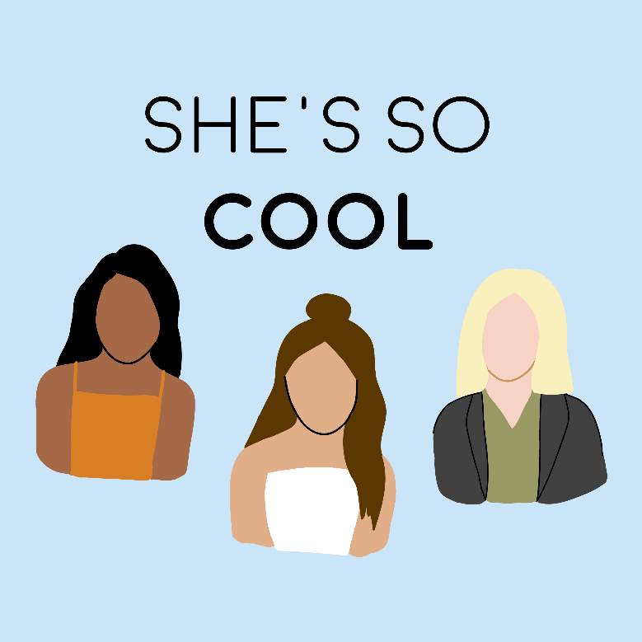

Trailer
She’s So Cool is a female empowerment podcast about women whose life stories will inspire you to embrace who you are, love yourself fiercely, and pursue your dreams.
SHE’S SO COOL PODCAST
Questions, comments, suggestions? Email me at shessocoolpod@gmail.com
Signup for podcast updates and exclusives, provide episode suggestions, and find show notes on www.shessocoolpod.com
For beautiful illustrations, inspiring quotes, and podcast updates, follow @shessocoolpod on Instagram.
You can listen to the She’s So Cool on:
Apple Podcasts // Google Play // Spotify // Stitcher // TuneIn
Cover art created by Gabrielle Bourgeois:
Instagram // Website
Music by Broke For Free:
Instagram

